Using OpenCodeList with Juypter Notebooks

This document will help you use a code list from <https://www.opencodelists.org/> to find data in the Connected Bradford primary Care database.

There are some very useful videos on this website that detail how to use it to create a list of codes. You will need to ensure that the codelist you use is the one that the source data is using. In this particular case I have used the CTV3 codes to build a list of codes related to “Tuberculosis”.

I then downloaded this to my local machine as a csv.

We then need to open our notebook and “upload” this csv.

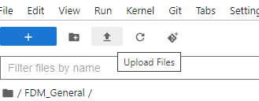

I’m now going to load this csv into a table in my project space . I’ll do this using a R notebook



The script above reads the name of the csv. It then creates a table in the CB_MYSPACE_JDB dataset called tuberculosis.

Next I’m going to query the Primary Care FDM to find any person in the tbl_srcode data with any of these codes. I’ll join my new tuberculosis table, with the tbl_srcode table and also with the person table. This is the table that contains all the demographic data for this fdm. This then loads this data into a R data frame.

This script is here :



Done ! Good luck !